# Digital Control: Exercise 7

Xu Fei feixu12@student.hh.se

## Basic theory

1. **Simplified servo dynamics with dry friction**

Servo dynamics with dry friction is describe as

$$\dot{x}\left(t\right)=f(u(t))$$

Where $x$ is the servo position, $u$ control input (voltage) and $f$ defined as:

$$f\left(u\right)=sign(u)∙max⁡(\left|u\right|-d,0)$$

When the input is increasing from zero the servo output is not moving until the input exceeds the friction force parameter $d$ (here $d=0.1$). Thus, the servo is stuck and cannot move until enough input is generated.

1. **Discrete-time model**

Without the friction $(d=0)$, zero-order-hold sampling gives the linear model

$$x\left(k\right)=\frac{hq^{-1}}{1-q^{-1}}u(k)$$

For inputs that exceed the friction the system behaves as if there were a constant disturbance $d$. Thus, it should be possible to eliminate it with integral action, at least as long as $u$ does not change sign. If this happens, the disturbance also changes sign. The linear model can therefore be described as (using $h=1$)

$$\left(1-q^{-1}\right)x=q^{-1}\left(u+d\right), d=\left\{\begin{aligned}0.1 u>0.1 \\ -0.1 u<-0.1\end{aligned}\right.$$

## Tracking constant references

Investigate the following different controller designs for tracking a manually chosen constant set point. Open the Sysquake-file *Servo.sq*. The controller in standard structure controls the servo model that described in part1. The standard structure is:

$$Ru=-Sy+Tr$$

Default is manual control which means that $R=T=1$ and $S=0$, i.e. $u=r$.

The reference can be manipulated with the mouse by clicking on the black circle and moving it horizontally. The red circle is the servo output.

1. P-controller with $A_{c}=1$ (dead-beat design).

$$x\left(k\right)=\frac{hq^{-1}}{1-q^{-1}}u\left(k\right)=\frac{q^{-1}}{1-q^{-1}}u\left(k\right)$$

Then we can get:

$$A=\left[1,-1\right], B=[0, 1]$$

$${AR+BS=A}_{c}=1$$

$$R=1-r_{1}q^{-1}, S=s_{0}+s_{1}q^{-1}$$

$$T=\frac{A_{c}}{B}\left(1\right)=S\left(1\right)=1$$

So we can get that:

$$\left(1-q^{-1}\right)\left(1-r_{1}q^{-1}\right)+q^{-1}\left(s_{0}+s_{1}q^{-1}\right)=A_{c}=1$$

For P-control system, we know $r_{1}=0$

$$→\left\{\begin{aligned}r_{1}+s_{1}=0 \\ s_{0}-1-r_{1}=0\end{aligned}\right.$$

$$→\left\{\begin{aligned}s_{1}=0 \\ s_{0}=1\end{aligned}\right.$$

Then we can get:

$$T=1, R=1, S=1$$

Then we set it in the servo control system, the result is shown in figure 2.1.

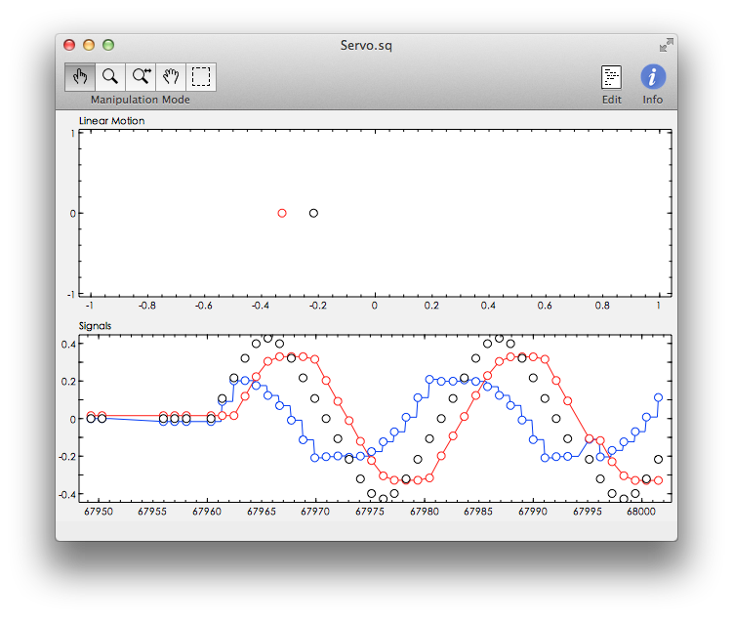

Figure 2.1 Servo system when $T=1, R=1, S=1$

1. A controller with integral action and $A_{c}=1$.

$$x\left(k\right)=\frac{hq^{-1}}{1-q^{-1}}u\left(k\right)=\frac{q^{-1}}{1-q^{-1}}u\left(k\right)$$

Then we can get:

$$A=\left[1,-1\right], B=[0, 1]$$

$${AR+BS=A}_{c}=1$$

$$R=1-r_{1}q^{-1}, S=s_{0}+s_{1}q^{-1}$$

$$T=\frac{A_{c}}{B}\left(1\right)=S\left(1\right)=1$$

So we can get that:

$$\left(1-q^{-1}\right)\left(1-r_{1}q^{-1}\right)+q^{-1}\left(s_{0}+s_{1}q^{-1}\right)=A_{c}=1$$

For P-control system, we know $r_{1}=1$

$$→\left\{\begin{aligned}r_{1}+s_{1}=0 \\ s_{0}-1-r_{1}=0\end{aligned}\right.$$

$$→\left\{\begin{aligned}s_{1}=-1 \\ s_{0}=2\end{aligned}\right.$$

Then we can get:

$$T=1, R=1-q^{-1}, S=2-q^{-1}$$

Then we set it in the servo control system, the result is shown in figure 2.2.

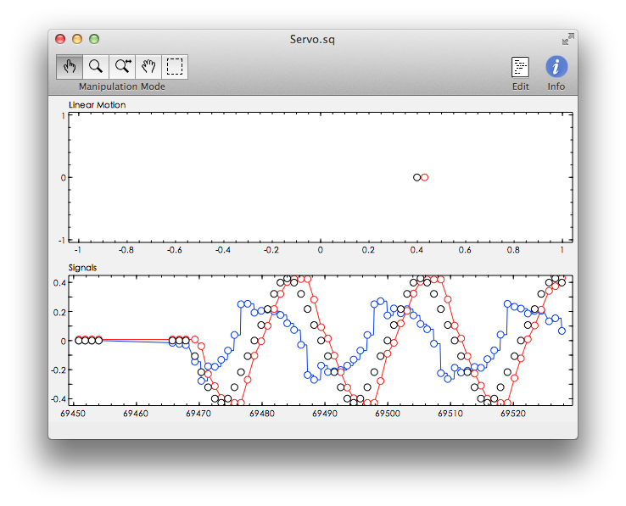

Figure 2.2 Servo system when $T=1, R=1-q^{-1}, S=2-q^{-1}$

From figure 2.1 and figure 2.2, we can see, in figure 2.1 (P-controller) the red circle will follow the black circle automatically, but there’s one step delay, and there’s also an error with the position because the friction disturbance, in the signal part, we can clearly see there’s an error on the peak of the black curve and red curve. However, in figure 2.2, we can see the delay is still exist, but the error on the peak of the on the peak of the black curve and red curve has been eliminated.

## Tracking a triangular-like reference

A triangular-like reference is now generated. It is a Fourier-series approximation of a triangular wave and described as:

$$r\left(k\right)=\frac{N}{D}δ\left(k\right), D=D_{1}D_{2}$$

Where $D_{i}=1-2\cos\left(ω_{i}\right)q^{-1}+q^{-2}, i=1,2$ and $ω_{1}=2π/20$, $ω_{2}=3ω_{1}$. Neither of the above controllers will now be able to track the moving reference without error. This is partly because the T-polynomial needs to be redesigned and partly because of the disturbance.

1. Change the T-polynomial in controller **1b** above, and design it based on the annihilation polynomial **D**.

As we known:

$$D_{i}=1-2\cos\left(ω_{i}\right)q^{-1}+q^{-2}, i=1,2$$

We can get:

$$D_{1}=1-2\cos{\frac{2π}{20}}q^{-1}+q^{-2}=1-1.9021q^{-1}+q^{-2}$$

$$D_{2}=1-2\cos{\frac{6π}{20}}q^{-1}+q^{-2}=1-1.1756q^{-1}+q^{-2}$$

$$→D=D_{1}D_{2}=(1-1.9021q^{-1}+q^{-2})(1-1.1756q^{-1}+q^{-2})$$

$$→D=D_{1}D_{2}=1-3.0777q^{-1}+4.2361q^{-2}-3.0777q^{-3}+q^{-4}$$

Base on annihilation polynomial D, we have:

$$BT+DM=A_{c}$$

We already get $A=\left[1,-1\right], B=[0, 1]$, so here I calculate in Matlab to get $T$ and $M$.

$$q^{-1}T+\left(1-3.0777q^{-1}+4.2361q^{-2}-3.0777q^{-3}+q^{-4}\right)M=A_{c}=1$$

$$→\left\{\begin{aligned}M=1 \\ T=[3.0777, -4.2361,3.0777,-1]\end{aligned}\right.$$

$${AR+BS=A}_{c}=1$$

We already get $R$ and $S$ from 1b):

$$R=1-q^{-1}, S=2-q^{-1}$$

Then we can get:

$$T=\left[3.0777, -4.2361,3.0777,-1\right], R=\left[1,-1\right], S=[2,-1]$$

Then we set it in the servo control system, the result is shown in figure 3.1.

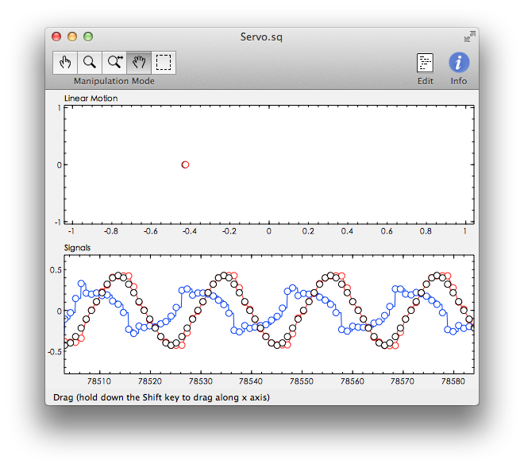

Figure 3.1 $T=\left[3.0777, -4.2361, 3.0777,-1\right], R=\left[1,-1\right], S=[2,-1]$

From the result, we can found the delay error is much smaller than the origin PI-controller (figure 2.2), but it still has delay error.

1. Use the calculated $T$ above but change the design for $R$ and $S$ for robust tracking. Thus, because of the reference shape the disturbance can be modeled by the annihilation polynomial $R_{f}=1+q^{-10}$, since $d\left(k\right)=-d (k-10)$. Consequently, use $R_{f}$ as fix factor in $R$. Choose $A_{c}$ = 1.

$$d\left(k\right)=-d (k-10)$$

We can assume:

$$R=R_{1}R_{f}$$

$${AR+BS=A}_{c}=1$$

$${→AR_{1}R_{f}+BS=A}_{c}=1$$

So we can get that:

$$(1+q^{-10})\left(1-q^{-1}\right)R_{1}+q^{-1}S=A_{c}=1$$

$$→(1+q^{-10})\left(1-q^{-1}\right)R_{1}+q^{-1}S=A_{c}=1$$

$${→R}_{1}-R_{1}q^{-1}+R_{1}q^{-10}-R_{1}q^{-11}+Sq^{-1}=1$$

$$→\left\{\begin{aligned}R_{1}=1 \\ S=[1,0,0,0,0,0,0,0,0,-1,1]\end{aligned}\right.$$

$$→\left\{\begin{aligned}{R=R}_{1}R_{f}=[1,0,0,0,0,0,0,0,0,0,1] \\ S=\left[1,0,0,0,0,0,0,0,0,-1,1\right] \end{aligned}\right.$$

And we already get $T$ from 2a), $T=\left[3.0777, -4.2361, 3.0777,-1\right]$

Then we set it in the servo control system, the result is shown in figure 3.2.

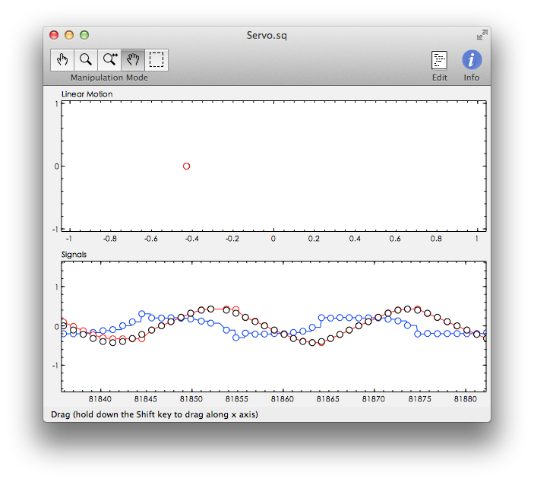

Figure 3.2 $T=\left[3.0777, -4.2361, 3.0777,-1\right]$

$$R=\left[1,zeros\left(9\right),1\right], S=[1,zeros\left(8\right),-1,1]$$

From the result we can see that the red circle is exactly at the same position as black circle, and there’s no delay error anymore.